My story is a long and a sordid mess. As I am sure that yours is also. We all have a different story. One that is specific to us and one that is specifically chosen to help someone else through theirs. Regardless of our story, we are meant to use it for God’s glory. He is a God of love and Jesus is the Savior, the Redeemer. We are loved and redeemed, even within our story.
Psalm 66:16 “Come and listen, all you who fear God, and I will tell you what he did for me.”
Our story is not to be limited to only those who fear God, our story is to be carried out among those who do not know HIM yet. Giving others HOPE for a new and better tomorrow. Showing them that the God who loves us, even in our sin, loves them. 1 John 1:2-3 “This life was revealed to us, and we have seen it and testify about it. We declare to you this eternal life that was with the Father and was revealed to us. What we have seen and heard we declare to you so that you, too, can have fellowship with us. Now this fellowship of ours is with the Father and with his Son, Jesus, the Messiah.” No one is left behind if they ask Jesus to be with them.
I was raised in what most would say was a normal all-american home but was not raised in church. I did all the things a girl would do growing up. A neighbor ministered to me and I was baptized during my junior year of high school. I got married right out of high school to the man of my dreams, had children and found myself divorced 10 years later. Divorced and two kids, I re-married quickly, now almost 30 years ago.
I know this sounds like a million other women’s stories out there. But what is not like a million others out there is all the words left unsaid in between. All the sordid and messy parts that were left unsaid and little by little erupted during the middle of those years. All the parts that were so ingrained in my mind and guided my way until the day that I let it all go. I finally allowed Jesus to do what he came here to do and that was to redeem me from my past and save me of my sin. And oh, what a glorious day that was. Galatians 2:20 “I have been crucified with Christ. It is no longer I who live, but Christ who lives in me. And the life I now live in the flesh I live by faith in the Son of God, who loved me and gave himself for me.”

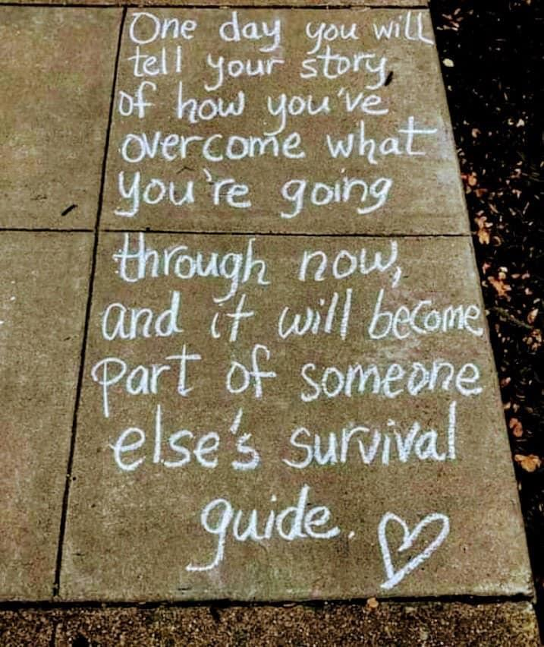
What I have found during this time of erupting and redemption is that there were many that had been through those unsaid parts or were still going through them. It was by the sharing of my own unsaid parts that others were able to find hope for a day of letting go and allowing Jesus to redeem them also. 1 Peter 3:15 “But in your hearts honor Christ the Lord as holy, always being prepared to make a defense to anyone who asks you for a reason for the hope that is in you; yet do it with gentleness and respect,”
As a people, of sordid and messy parts, we must remember that God will use those parts to mold us into the people that He created us to be. We can choose to be bitter and angry or we can choose to embrace HIS love and use our parts to make us stronger and more compassionate people. It is our choice. HE gives us that option. But the choice we make will always determine our future and possibly the future of someone else.

Our sharing of those parts, shows the glory of God and how he will work in the lives that those who invite him in. 2 Timothy 1:8 “Therefore do not be ashamed of the testimony about our Lord, nor of me his prisoner, but share in suffering for the gospel by the power of God,”.

We can also be a light that glorifies HIM as we walk through hard times. Showing others how trusting in HIM will give us the peace in our soul that is needed to weather storms that are sure to come. Isaiah 41:10 ,” So do not fear, for I am with you; do not be dismayed, for I am your God. I will strengthen you and help you; I will uphold you with my righteous right hand”
What story are you supposed to share?
Rhonda Gould, is an ICF coach working on her ACC and an author for Christian Coaching Magazine. She specializes in helping women reveal patterns that are holding them back. She believes that every client has the ability within themselves to break the patterns and promote forward movement into career opportunities, new relationships, fun adventures and so much more. Rhonda consults with clients centered around having healthy boundaries and dealing with difficult people and hard conversations. You can learn more about Rhonda’s work at https://rhondagouldonline.com/.

