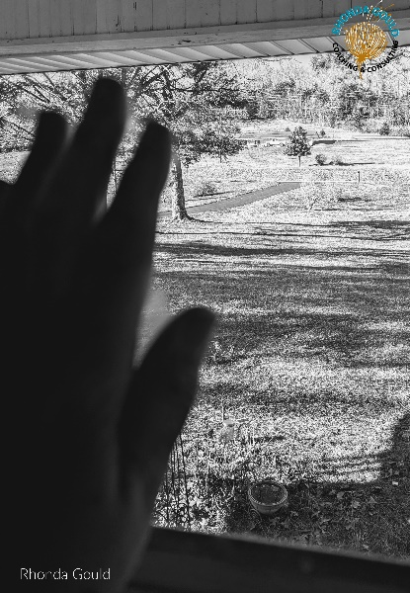
As the new year starts, we might find ourselves evaluating our lives and what might need to be changed and improved on. This is a good and beneficial practice to have at any point of the year, but we tend to be hyper-focused on such things with the newness and beginning of a new year. Health and wellness is a BIG ONE for a lot of folks and usually focusing more on physical health. But one thing we all take for granted and don’t put as much emphasis on is our mental health. And one sure fired way to fight mental illness is with strong relationships. According to the National Counsel for Mental Health, “Friendship is something you never outgrow. Older adults who are “living a socially active life and prioritizing social goals are associated with higher late-life satisfaction.””

Scripture even talks about the importance of having people in your circle in Ecclesiastes 4:9-12 “Two are better than one, because they have a good reward for their toil. For if they fall, one will lift-up his fellow. But woe to him who is alone when he falls and has not another to lift him up! Again, if two lie together, they keep warm, but how can one keep warm alone? And though a man might prevail against one who is alone, two will withstand him—a threefold cord is not quickly broken.”

What does your relationships look like? Did you know that friendships are vital to your health? I, personally, knew they were important to me but didn’t realize just how important. Loneliness is the #1 in the reasons for these health risks. You don’t have to be alone to be lonely either. I know that I’ve been in a room full of people and felt loneliness. Have you? If we were being honest, we all could answer “Yes” to that question.
The fact is that there are real facts about your health and loneliness:
- Loneliness is likely to increase your risk of death by 26% (Holt-Lunstad, 2015)
- Loneliness, living alone and poor social connections are as bad for your health as smoking 15 cigarettes a day. (Holt-Lunstad, 2010)
- Loneliness is worse for you than obesity. (Holt-Lunstad, 2010)
- Loneliness and social isolation are associated with an increased risk of developing coronary heart disease and stroke
- Loneliness increases the risk of high blood pressure
- Loneliness with severe depression is associated with early mortality and loneliness is a risk factor for depression in later life
- Loneliness and social isolation put individuals at greater risk of cognitive decline and dementia
So now that you know the risks of being lonely, what are you going to do about that? What are you doing to increase your relationships and deepen them? Or are you waiting for them to come to you. I know it’s scary to reach out, and easier to just wait, but no activity leads you to no activity.
I love a new book that I just read Are You Really OK? by Debra Fileta, which talks about "faking fine"? We all tend to think we're OK---until we're not. Challenging you to get real, and helps you define where you need spiritual, emotional, mental, and physical healing. Discover how to get to the root of what you believe about yourself, God, and others.
If you know someone who won’t reach out, PLEASE make that first step for them. If you are lonely, know that you don’t have to be.
For more information https://www.campaigntoendloneliness.org/the-facts-on-loneliness/
For more information https://halftimeinstitute.org/2018/12/19/5-essential-questions-for-leaders-seeking-lasting-friendships/?gclid=Cj0KCQiAq7COBhC2ARIsANsPATForQ0StbLsGiADad-KtPoOAW9KLe2EUMOQDuxR52lGKdIMs3XKr60aAq2eEALw_wcB
For more information https://www.mentalhealthfirstaid.org/2019/08/why-healthy-friendships-are-important-for-mental-health/
Contact me at rhondagouldonline.com/contact-for-free-initial-session/ to start the process of being OK……… Really!

Rhonda Gould, is an ACC Certified life coach through the ICF. She specializes in helping others reveal patterns that are holding them back. She believes that every client has the ability within themselves to break the patterns and promote forward movement into career opportunities, new relationships, fun adventures and so much more. Rhonda consults with clients centered around having healthy boundaries and dealing with difficult people and hard conversations. You can learn more about Rhonda’s work at https://rhondagouldonline.com/. Initial coaching session is FREE!

